CHAPTER FOUR
SYSTEM IMPLEMENTATION

4.1 Chapter Overview
This chapter focuses on the implementation phase of the system titled "Development of a Digital Surveillance System for Pandemic Outbreak in Calabar Metropolitan." It provides a detailed explanation of how the proposed system was translated from design into a working software solution. The implementation process involved selecting appropriate technologies, structuring the system architecture, integrating individual components, and ensuring seamless functionality through rigorous testing.
The chapter begins by highlighting the system's key features and the justification for choosing each technology used in the development. It further explores the different testing strategies employed to ensure the reliability, usability, and security of the system. This includes unit testing, integration testing, system testing, usability evaluation, and security assessments. The minimum and recommended system requirements for running the application are outlined to guide deployment and usage.
Finally, the results of testing are discussed to determine the extent to which the system meets its intended objectives. A general discussion wraps up the chapter, reflecting on the system’s performance, practical benefits, and identified limitations. The ultimate goal of this chapter is to demonstrate how the implemented system supports real-time disease surveillance and contributes to efficient public health management within the Calabar metropolitan area.

4.2 Features and Choice of Implementation Technology
The Digital Surveillance System for Pandemic Outbreak in Calabar Metropolitan was designed and implemented with core features that support efficient disease monitoring, real-time reporting, and visualization of health data. These features were built with a carefully selected stack of technologies, chosen for their suitability, performance, and compatibility with modern web development practices.
One of the key features of the system is the disease outbreak reporting interface. This module allows registered medical personnel to log into the system and submit detailed information about new cases, including disease type, symptoms, location, and the number of confirmed and treated cases. Each report is stored in a central database and is uniquely identified with a generated case ID. The report submission form includes validation rules to ensure that all required fields are correctly filled out before the data is stored.
Another critical feature is the interactive map, which provides a visual representation of outbreak data across various locations in Calabar. This functionality was implemented using Leaflet.js, a lightweight JavaScript library used for rendering dynamic and responsive maps. The map displays real-time markers with varying colors that indicate disease severity levels, from areas with no reports to those experiencing confirmed outbreaks. The use of geospatial visualization makes it easier for health officials to quickly identify hotspots and respond accordingly.
In addition to mapping, the system incorporates analytic dashboards and chart visualizations. Using Chart.js, an open-source charting library, the system presents graphical summaries of reported cases over time, comparisons of different disease types, and locations most affected. These visualizations help users understand patterns and trends, thus supporting data-driven decisions.
User authentication and access control were also integrated to maintain data security. Only approved medical personnel can log in, report outbreaks, or view personalized dashboards. The system enforces account approval by the administrator before a user is granted access. Session management using Django’s session framework helps protect user data while maintaining a seamless login experience.
Email alert notifications were added as a proactive feature to enhance outbreak response. When a report surpasses defined thresholds for confirmed cases, an automated email is triggered to notify health authorities of a potential or confirmed outbreak. This integration was achieved using Django's built-in email framework with SMTP configuration for Gmail, allowing timely communication of critical information.
The following technologies were carefully chosen to implement these features:
- HTML, CSS, and JavaScript formed the foundational layer for designing the system’s user interface. HTML structured the content, CSS styled the layout for responsiveness and aesthetics, while JavaScript was used to handle dynamic interactivity and real-time form validation.
- Python (Django) was selected as the backend framework because of its simplicity, scalability, and robust support for rapid development. Django's Model-View-Template (MVT) architecture facilitated a clean separation between data logic, interface design, and business rules.
- Leaflet.js was employed for map rendering due to its ease of integration with existing datasets and its efficient handling of geographical overlays, including circles and custom markers.
- Chart.js was used for data visualization because it supports various chart types and integrates smoothly into Django templates via JavaScript.
- MySQL served as the system’s relational database management system. It was chosen for its reliability, scalability, and compatibility with Django’s ORM (Object-Relational Mapping) tools.
- SMTP Email Services (via Gmail) were incorporated to enable real-time alert notifications to designated email addresses when threshold conditions for disease spread are met.
Overall, the combination of these technologies ensured that the system was not only functional and user-friendly but also scalable and secure for real-world use in public health surveillance.

4.3 System Testing Strategies
To ensure that the Digital Surveillance System for Pandemic Outbreak in Calabar Metropolitan functioned as intended and met its design requirements, a range of systematic testing strategies were adopted. These strategies addressed different aspects of the system, from individual functionalities to overall performance, during and after development.
- Unit Testing was conducted at the early stage to evaluate specific components in isolation. This included testing individual Python functions, Django model methods, and JavaScript event listeners. For instance, the function responsible for calculating active cases, as well as the session-based login system, were tested separately to ensure accuracy.
- Integration Testing was then performed to confirm that different modules worked harmoniously. This included checking the flow of data between the outbreak submission form (frontend), the AJAX request handler (JavaScript), the backend endpoint (Django view), and the database (MySQL). It also involved validating that user sessions maintained correct state across navigation.
- Usability Testing involved observing real users interact with the system to gather feedback about its design and ease of use. Sample users from a healthcare or technical background were asked to register, log in, report an outbreak, and interpret analytics from the dashboard. Their feedback led to improvements in form layout, error messages, and overall responsiveness.
- Validation Testing ensured that all input data met expected formats and constraints. The system was tested with both valid and invalid data to verify that it rejected empty or incorrect submissions. Fields such as email address, case ID, disease type, and numeric inputs like confirmed cases were strictly validated both on the frontend and backend.
- Security Testing focused on access control, session protection, and data confidentiality. The system was examined to verify that only approved users could access the dashboard. Passwords were stored securely using hashing. Cross-site request forgery (CSRF) protection was enforced using Django’s CSRF tokens, and session management was tested to confirm automatic logout after invalid login attempts or session timeout.
- System Testing was carried out to evaluate the overall performance and coherence of the entire application. The full system was deployed locally and accessed using multiple browsers and devices. Tests included map interaction, real-time report updates, disease analytics rendering, user navigation, and email alert delivery. All modules were tested together in realistic usage scenarios to ensure the end-to-end workflow was seamless and robust.
These testing strategies collectively validated the functionality, reliability,
usability, and security of the system, ensuring that it could be confidently deployed for real-world disease surveillance in Calabar.

4.4 Target Computer System Requirements
The system was designed to be lightweight, browser-based, and compatible with standard computing environments. The table below outlines both the minimum and recommended system requirements for running and accessing the application:
COMPONENT | MINIMUM REQUIREMENT | RECOMMENDED REQUIREMENT
Processor | Intel Core i3 / AMD Ryzen 3 or equivalent | Intel Core i5 or higher / AMD Ryzen 5 or higher
Ram | 4 GB | 8 GB or more
Storage | 10 GB available disk space | 20 GB SSD or more
Operating system | Windows 8 / macOS 10.12 / Linux Ubuntu 18.04 | Windows 10 or higher / Latest macOS / Ubuntu 20.04+
Browser | Chrome, Firefox, or Edge (latest 2 versions) | Google Chrome (latest version)
Internet | Basic internet connection (512 kbps minimum) | Broadband connection (2 Mbps or higher)
Dependencies | Python 3.9+, Django 4+, MySQL 8.0, Leaflet.js, Chart.js | Same, with updated patches

The application can be deployed on a local machine for testing purposes or hosted on a cloud server for remote access. The use of web technologies such as HTML, CSS, and JavaScript ensures cross-platform compatibility, while the Django framework and MySQL database require moderate backend resources. It is recommended that the hosting environment be secured and scalable to support concurrent users in real-world deployment scenarios.

4.5 Results of Testing
The testing phase of the digital surveillance system was conducted after the successful implementation of the core modules. These included user registration and approval, login authentication, outbreak reporting, real-time map visualization, data analytics, and automated email notifications for potential outbreaks. The objective of the testing was to ensure that each component worked as intended and that the system met the design and functional requirements specified in earlier phases.
The outcome of unit testing revealed that individual components of the system performed correctly when tested in isolation. Functions such as password validation, email uniqueness checks, disease dropdown logic, and map marker generation were tested with both valid and invalid inputs. The system consistently provided accurate responses. For example, when attempting to register with mismatched passwords, the system returned an appropriate error message.
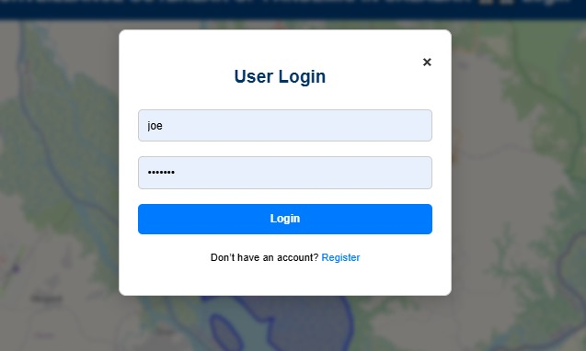


Fig 4.5.1: Unit test – Password mismatch error
During integration testing, multiple modules were tested together to ensure that they functioned seamlessly as a whole. After a health personnel successfully registered and their account was approved by the admin, the login process granted access to the personalized dashboard. Submitted outbreak reports were correctly saved to the database, reflected on the Leaflet.js map, and summarized in the analytical charts powered by Chart.js.

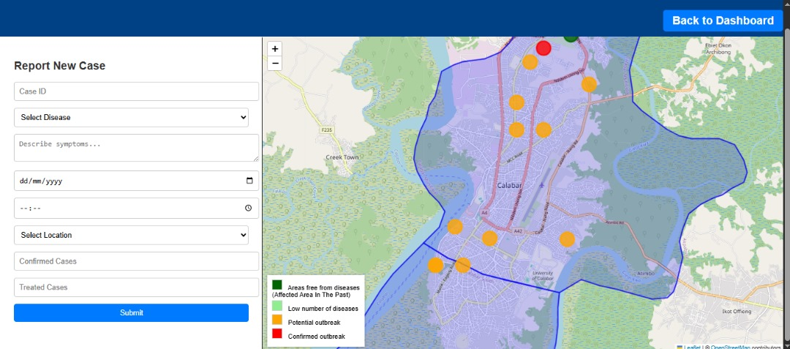
Fig 4.5.2: Integration – Report submitted and reflected on map

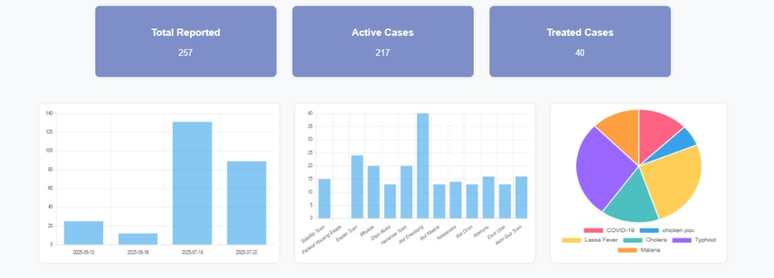

Fig 4.5.3: Integration – Data reflected in analytics chart

Usability testing was performed by a select group of test users, including medical students and supervisors. They were asked to navigate through the system without assistance. The testers found the interface simple and professional, with clear labels, helpful error prompts, and intuitive form controls. One user highlighted that the dynamic behavior of form elements (e.g., showing a custom disease field only when “Other” was selected) enhanced their experience. Minor suggestions, such as making form validation errors more prominent, were implemented in the final release.
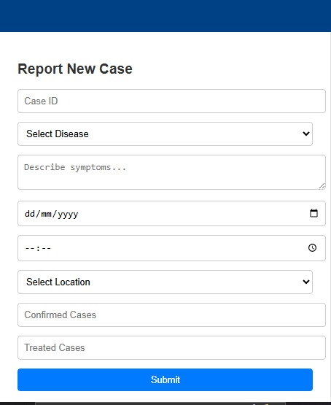

Fig 4.5.4: Usability – Simple outbreak form report

Validation testing focused on comparing the behavior of the system with the expected outcomes based on the system’s functional specification. All major functionalities were verified: registration flow, login restriction for unapproved users, disease reporting, active case tracking, map visualization, and email alerts. In each case, the actual behavior matched the expected result. For example, submitting a report with over 25 confirmed cases triggered an email alert to the health authority email account.

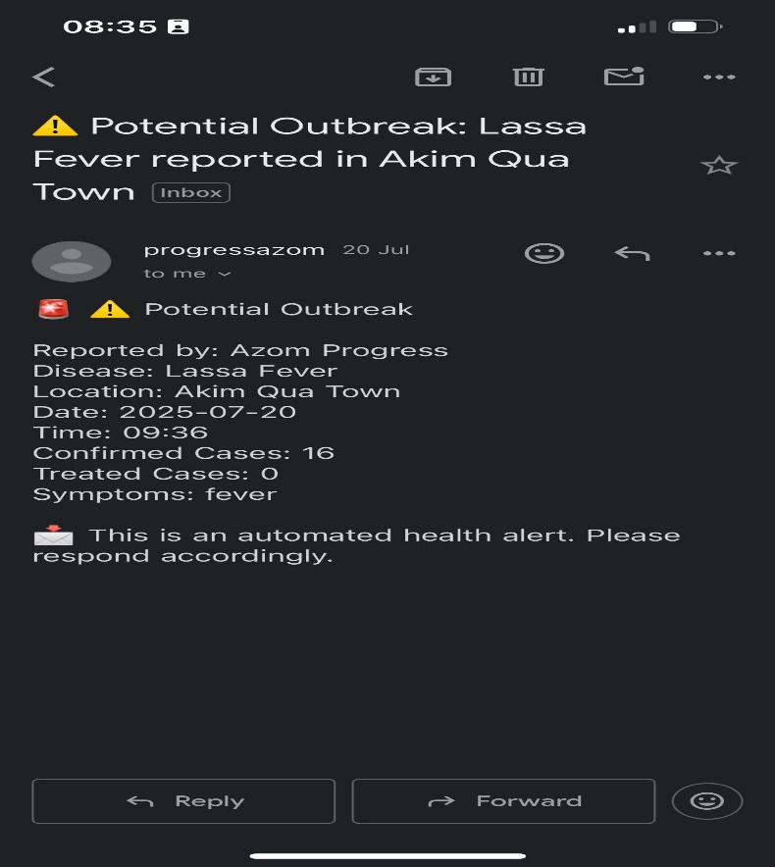

Fig 4.5.5: Validation – Email alert triggered for confirmed outbreak

Security testing ensured the system was not vulnerable to unauthorized access or data exposure. Passwords were hashed using Django’s secure algorithms, and login sessions were managed via Django’s session middleware. Attempts to access the dashboard or submit reports without logging in were blocked and redirected to the login modal. Additionally, unapproved users were prevented from accessing system functionalities until manually approved.
System testing was conducted in a complete runtime environment. The application was tested on a local server running Django, using MySQL as the backend. The map rendered correctly on desktop and mobile viewports, and form submissions worked even under simulated moderate network latency. No critical errors were encountered during testing, and the application remained stable with consistent performance throughout.

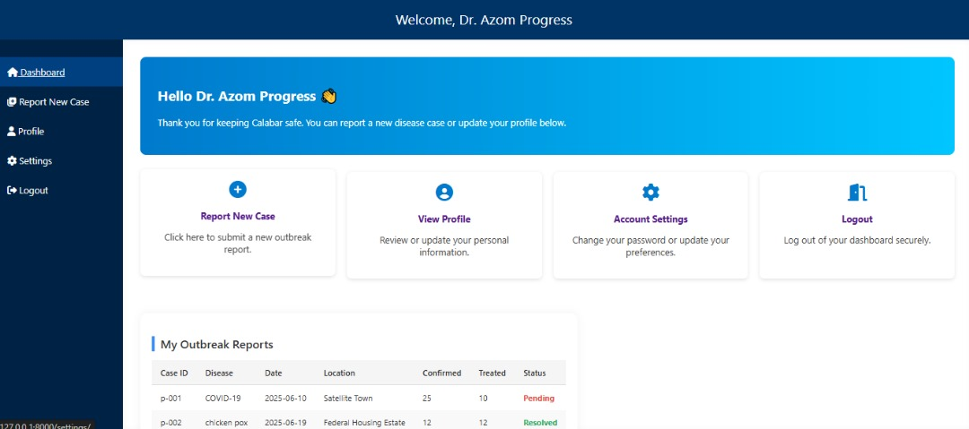

Fig 4.5.6: System – Full view of dashboard with personalized greeting

The testing process proved that the digital surveillance system met its core objectives. All required functionalities performed as expected, and no major bugs or breakdowns were observed. The attached screenshots serve as visual confirmation of the working system and highlight key stages and interactions during the testing phase.

4.6 Discussion
The implementation and testing phases of the digital surveillance system for pandemic outbreaks in Calabar Metropolitan revealed that the system effectively meets its design objectives. Through a web-based interface, health personnel are now able to report disease outbreaks in real time, visualize affected areas on an interactive map, and trigger automated alerts when outbreaks exceed certain thresholds. The platform provides a centralized and intelligent method of tracking potential and confirmed disease threats, particularly within a resource-constrained urban environment.
The results demonstrated that the core features, such as secure login for verified medical personnel, location-based reporting, visual analytics using charts, and disease markers on the map, worked cohesively and reliably. These outcomes confirm the suitability of the technology stack (HTML, CSS, JavaScript, Leaflet.js, Django, and MySQL) for building an efficient, scalable, and responsive surveillance system.
The outbreak map integration via Leaflet.js was instrumental in helping users intuitively interpret the geographic spread of diseases. By employing color-coded circle markers, the system allows medical officials to distinguish between regions with no outbreak, low activity, potential outbreaks, and confirmed outbreaks. This real-time visual aid is critical for early intervention and resource allocation.
A notable strength of the system is its ability to send automated email alerts to health authorities once a report exceeds a predefined number of confirmed cases. This feature not only enforces real-time responsiveness but also reduces the dependence on manual monitoring and communication. The threshold logic was validated during testing, and all alerts were successfully delivered through the configured SMTP email system.
The personalized dashboard serves both as a command center and a reporting hub for each registered medical user. It displays outbreak summaries submitted by the user, enables case tracking, and provides quick access to profile and settings. This personalization fosters a sense of accountability and encourages consistent reporting from individual health centers across Calabar.
Despite the positive results, some limitations were observed. The system currently does not support multi-language functionality, which may affect inclusivity. Also, the reliance on manual administrative approval before access is granted, although useful for security, may introduce delays in situations where immediate access is needed. Furthermore, the current system does not feature predictive analytics or machine learning capabilities to forecast outbreaks based on trends, which could be an area of future enhancement.
In real-world relevance, this system demonstrates how digital tools can be adapted to local health challenges. Calabar, like many urban centers, faces threats from recurring diseases such as malaria, cholera, typhoid, and Lassa fever. The surveillance system provides a lightweight, practical, and effective framework for community-based disease monitoring and response coordination.
In conclusion, the system not only fulfills academic and technical requirements but also presents significant practical value to health administrators and frontline health workers. Its modular design, interactive visualizations, and automated communication features make it a useful digital tool in the ongoing fight against infectious disease outbreaks in Calabar and potentially other metropolitan areas with similar health challenges.

